Software Requirements Specification for Banking System

# ***INTRODUCTION:***

The Bank Account Management System is an application for maintaining a person's account

in a bank. In this project I tried to show the working of a banking account system and

cover the basic functionality of a Bank Account Management System. To develop a project

for solving financial applications of a customer in banking environment in order to nurture

the needs of an end banking user by providing various ways to perform banking tasks. Also

to enable the user’s workspace to have additional functionalities which are not provided

under a conventional banking project.

## Requirements

* **Functional Requirements:**

Purpose

To register a new customer

• Inputs

The required data for registration of a new customer in the bank (Like

Name, Address, Designation etc) • Output

A Success Message be displayed on successful registration or else an

error message will be displayed.

* **Non- Functional Requirements:**

Non-functional requirements are requirements that are not directly concerned with the specific functions delivered by the system. They may relate to emergent system properties such as reliability, response time and store occupancy. They may specify system performance, security, availability, and other emergent properties.

**1): Safety Requirements:**

Backup, recovery & business continuity Banks should ensure adequate back up of data as may be required by their operations. Banks should also have, well documented and tested business continuity plans that address all aspects of the bank’s business.

**2): Security Requirements**:

a. Account ID and Password (PIN) Protection

b. Sign-off Button

c. Failed Log-on Attempts

* **Software Requirements:**

1): Visual Studio

2):MS SQL

**Waterfall model**

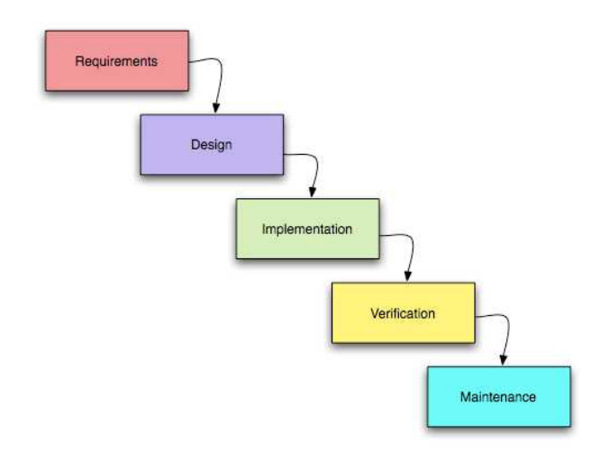

**DESIGN & IMPLEMENTATION**

1) Class Diagram

2) Use-case Diagram

3) E-R Diagram

**Use-case Diagram**

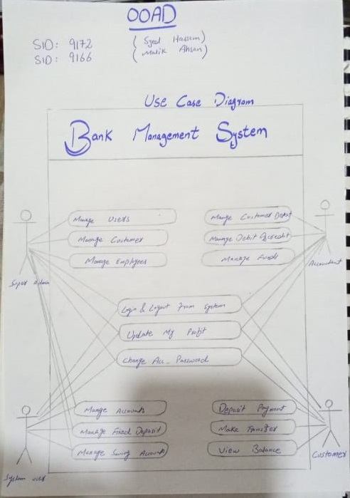

**E-R Diagram**

